Master Installer Configuration Instructions

Introduction
The Master Installer Configuration tool is used to create master installers and CD images for any combinations of Products defined in the _Master Installer.xml file. (See XML configuration.doc should you wish to edit the XML file.)
This document explains how to use the Master Installer Configuration tool. The tool runs on Microsoft Internet Explorer version 6 or higher. The tool itself has a user interface defined via the referenced ConfigureMasterInstaller.xsl file.
The interface acts like a configuration wizard, with each screen having Next and Previous buttons. You should fill out the details on each page, and then press the Next button, until you get to the end.

0. Initialization

Make sure you have updated the files from the Subversion repositories Master Installer and Products, before launching the configuration tool.
Launch the tool by double clicking on the _Master Installer.xml file.
When the tool is first run, the browser shows the following security warning:

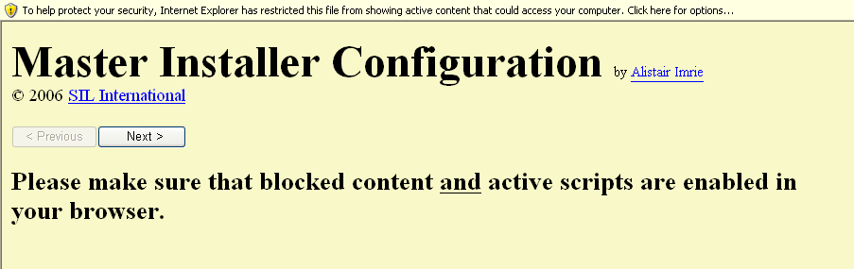

Click on the banner at the top, and select Allow Blocked Content… You will then get the following message boxes:

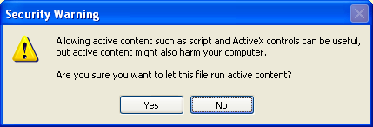 Click Yes on this one.

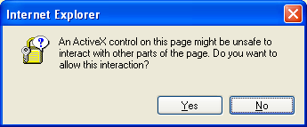 Click Yes on this one.

You will then see the Project Setup page.

1. Project Setup page

The Project Setup page looks something like this:

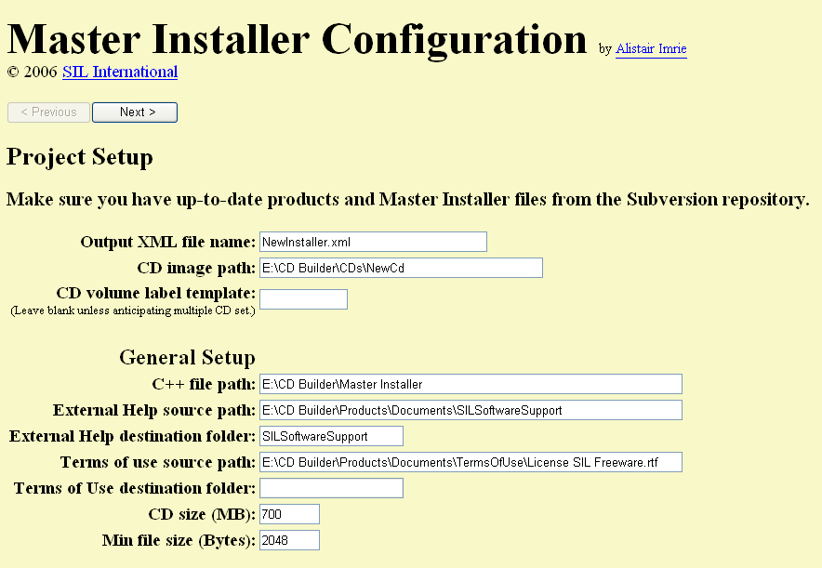

Output XML file name: The master installer will be compiled from a custom-made XML file. This XML file can subsequently be edited and re-compiled to alter the behavior of the master installer. Enter here the name for this XML file. It will be stored in a subfolder of the Master Installer folder, that subfolder having the same name as the new XML file, but without the .xml extension.
CD image path: If you opt to create a CD image, the files that make up the image, the CD image (ISO file) itself, and a copy of the XML file (see above), will all be stored in the folder whose full path is given here. The folder need not exist at this point.
CD volume label template: This is normally left blank, but if you anticipate needing more than one CD to fit all the software you will assemble, you can specify a CD volume label template here. Each CD will have a default volume label that consists of this template, with the integer index of the CD appended.
C++ file path: This is the path where the local copies of the C++ files (needed to compile the master installer) are kept. They originate from the Master Installer Subversion repository.
External Help source path: This is normally the root folder of the working copy of the Service Bulletins folder/file structure. It may be deleted if no Service Bulletins are to be included, or replaced with any general help file you wish to use. (It may be a folder or a file path, depending on whether the External Help is implemented as a set of files, or a single file.)
External Help destination folder: This is the relative path on the CD from the setup.exe to where the External Help (see above) files are to reside. Only set this if the External Help source path is a folder, not a file.
Terms of use source path: Similar in nature to the External Help source path, this is the path of the working copy of the Terms Of Use (license) folder/file structure for the whole CD (or CD set).
Terms of Use destination folder: Similar in nature to the External Help destination folder, this is the location on the CD of the Terms of Use folder structure. Only set this if the Terms of use source path is a folder, not a file.
CD size (MB): This is the capacity of the disks you will eventually release the software on.
Min file size (Bytes): This is used to calculate the space used on the target media. It is the amount of spaced used up on the media by a 1-byte file. This is typically 2048 Bytes.

2. General Configuration page

The General Configuration page looks something like this:

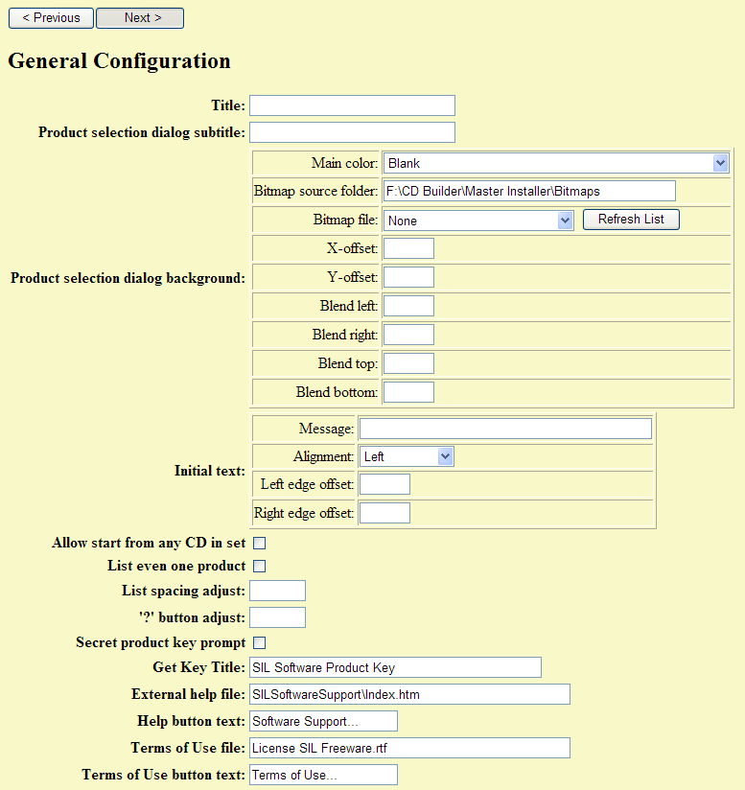

Title: The overall title of the master installer. This will appear on most of its dialog boxes.
Product selection dialog subtitle: This will be appended to the Title in the Product Selection dialog box. It is typically a copyright message.
Product selection dialog background: This is a collection of settings for defining the appearance of the Product Selection dialog box:
- Main Color: This is the default color of the background. You may select from a list of predefined colors, some of which may have specific meanings, for example whether the software may be copied freely or not.
- Bitmap source folder: A bitmap image may be used as the dialog background. This setting defines where to look for possible bitmap images.
- Bitmap file: This is the file name of the bitmap image to use as the background. If the image is smaller than the dialog box, the Main Color will show around the outside edge of the image.
- Refresh List: This button causes the Bitmap file list to be repopulated. It is normally used after altering the Bitmap source folder.
- X-offset: This is used to offset the bitmap image horizontally, relative to the left-hand edge of the dialog client space. A positive number moves the image to the right, a negative value to the left. The offset is measured in pixels.
- Y-offset: This is used to offset the bitmap image vertically, relative to the top edge of the dialog client space. A positive number moves the image down, a negative value up. The offset is measured in pixels.
- Blend left, Blend right, Blend top, Blend bottom: These values allow the bitmap image to be faded, from left to right and/or top to bottom. Each value is a percentage of image opaqueness – 100 means the image is totally present, 0 means it is absent. Intermediate values cause blending of the image with the Main Color. The values are set for each edge of the image, and the blending across the image is interpolated from the edges.
Initial text: This is a collection of settings for defining a message to appear at the top of the product selection list. It is normally used for special instructions only for testers:
- Message: The actual text of the message.
- Alignment: Defines how the left side of the text lines up with other controls in the dialog.
- Left edge offset: A value in pixels to offset the start of the text from its aligned location.
- Right edge offset: A value in pixels to offset the end of the text from its aligned location.
Allow start from any CD in set: Select this to allow the user to auto-run the master installer from any disk in a multi-disk set.
List even one product: Select this to show a list of products to the user even when there is only one product available. When this box is cleared, the user will have no opportunity to read the Terms Of Use (license) or External Help, in situations where only one product is available.
List spacing adjust: This is the number of pixels to increase the vertical spacing of lines in the product list. A negative value may be used, to decrease spacing.
'?' button adjust: Each product normally has a button beside it, so that the user can read setup information before committing to install it. This setting increases the size (both width and height) of the button. A negative value may be used, to decrease the size.
Secret product key prompt: Select this if you want the master installer to start up without asking the user for a product key, unless they are holding down the control and shift keys when it starts up. This is useful when the list of products is a mixture of locked and non-locked products, and you don’t want the average user to know the locked products are even there.
Get Key Title: This is the text that will be used as the title of the dialog box asking the user for their product key.
External help file: This is the relative path from the setup.exe on the disk to the file to be opened when the user presses the External Help button.
Help button text: This is the text that will be on the External Help button. If left blank, there will be no External Help button.
Terms of Use file: This is the relative path from the setup.exe on the disk to the file to be opened when the user presses the Terms Of Use button.
Terms of Use button text: This is the text that will be on the Terms Of Use button. If left blank, there will be no Terms Of Use button.

3. Product Selection page

The Product Selection page looks something like this:

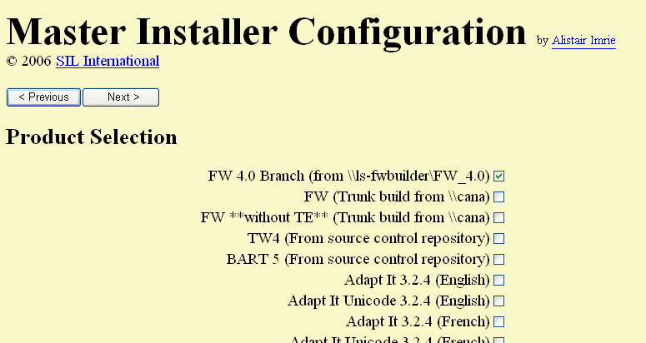

Select the products you want the user to be able to choose from the Product Selection dialog box. Note that prerequisite products and other required products will be added in automatically. Here you are just choosing products you want the user to be able to choose. Some products may appear to be listed more than once. Read them carefully to check for subtle differences, such as version numbers, source locations, etc.

4. CD allocation page

The CD allocation page looks something like this:

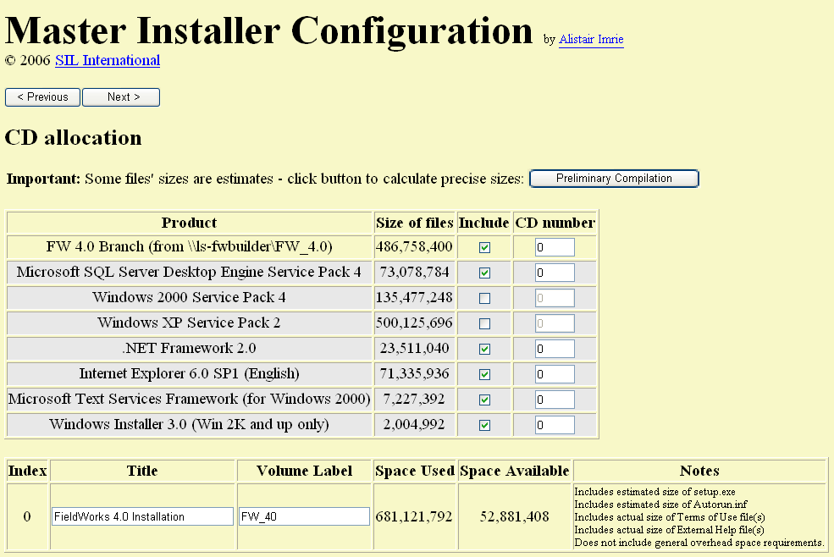

This page lists all the products that will go on the CD (set). The grey background indicates products that are needed by the products you selected, but which the user will not have any choice over.
The default is to have just one CD. If there is not enough room on one CD for everything, you can enter CD index numbers in the right-hand column to assign products to different CDs. You can opt to omit products altogether by clearing the corresponding check-box in the Include column. You might want to do this, for example to omit a Service Pack that you don’t think many users will need, which can be obtained over the internet, and which is very large.
The space available on each CD is a rough estimate, initially. The size of some files, such as the master installer itself, cannot be accurately known until it is compiled. You can press the Preliminary Compilation button to do this, and get a better estimate of the size requirements of files. Note, however, that even then the value is not totally accurate –the overheads of CD folder allocations are not known, for example.
The lower table on this page is where you set the title of each CD in the set. This is the name given to the user when the master installer prompts for a CD in the set to be inserted. You also set the volume label of each CD. This label will be used by the master installer to detect if the correct CD is present.

5. Ready to go page

The Ready to go page looks something like this:

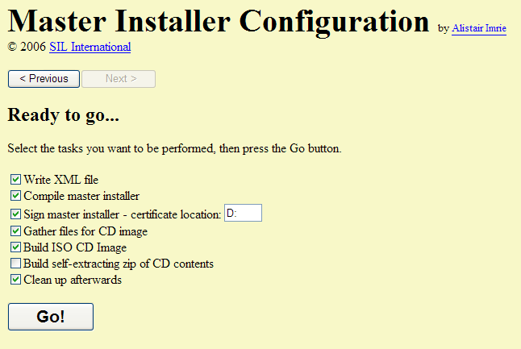

This page provides options for how much of the output process you want.
Write XML file: This creates the custom-made XML file mentioned in the Project Setup page. You can clear this box if you have already created the XML file, and you are re-running the tool to rebuild the ISO CD image, for example. If you have made any changes that would lead to a different XML file, or you have not previously generated the XML file for this project, you must select this option.
Compile master installer: Select this option to have the tool compile the setup.exe file based on your settings.
Sign master installer: Select this option to have the tool digitally sign the setup.exe file, using your digital certificate, whose location must be given in the box. When signing, you will be asked to enter the password for the private key of the certificate.
Gather files for CD image: Select this option to have the tool assemble all the required files and folders according to how they will appear on the CD (set). Each CD will be represented by a subfolder whose name will match the volume label of the CD. These subfolders will be in the CD image path folder mentioned in the Project Setup page.
Build ISO CD Image: Select this option to have the tool build an ISO file for each CD in the set. This requires that you have the MagicISO Console tool (miso.exe) either in C:\Program Files\MagicISO or somewhere in PATH. (MagicISO can be downloaded from www.magiciso.com, but costs $30 to run properly.)
Build self-extracting zip of CD contents: Select this option to have the tool compress the file/folder structure(s) containing the CD(s) contents (not the ISO file). This requires that you have the 7-zip files 7za.exe and 7zC.sfx in the Utils subfolder of the Master Installer working copy from Subversion.
Clean up afterwards: Select this to have the tool delete intermediate files that are produced during the compilation process. You might want to clear this, for example, if the compilation fails and you are trying to find out why.
Go! Press this button to start the activities selected above.

